Gestation Periods
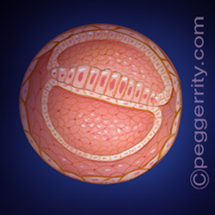
Four Weeks
- The brain and the spinal cord begin to form
- The heart begins to form
- The stomach and intestines are forming
- Bone tissue is growing
- The eyes and ears are just beginning to form
- The weight is less than 1 ounce
- The length is less than 1/8 inch
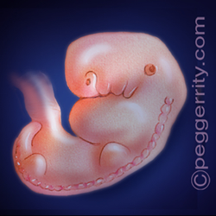
Six Weeks
- The lungs are beginning to form
- Brain activity can be recorded
- Eyes are present, but no eyelids yet
- The heart is more developed and is beating
- Early reflexes develop
- The hands and feet have fingers and toes, but may still be webbed
- The length is less than 1/4 inch
Six Weeks
- The lungs are beginning to form
- Brain activity can be recorded
- Eyes are present, but no eyelids yet
- The heart is more developed and is beating
- Early reflexes develop
- The hands and feet have fingers and toes, but may still be webbed
- The length is less than 1/4 inch
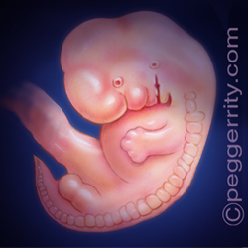
Eight Weeks
- All essential organs have begun to form
- Elbows and toes are visible
- The fingers have grown to the first joint
- Facial features - the eyes, nose, lips, and tongue - continue to develop
- The outer ears begin to take shape
- Organs begin to be controlled by the brain
- The length is about 1/2 to 3/4 inch
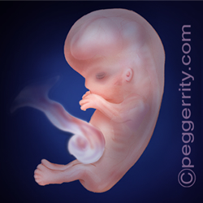
Ten Weeks
- The head is half the length of the body
- The arms and legs are long and thin
- The hands can make a fist with fingers
- Red blood cells are produced
- The length is about 1 1/4 to 1 3/4 inches
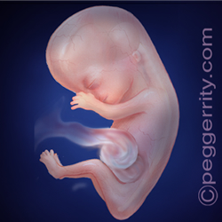
Twelve Weeks
- The neck is present and the face is well formed
- Tooth buds appear
- The arms and legs move
- All body parts and organs are present
- Definitive signs of male and female gender are present
- A heartbeat can be heard with electronic devices
- The length is about 2 to 3 inches

